Making Connections: Preparing for Funding Opportunities and Cross Border Collaboration

Organised by Irish Rural Link in partnership with Rural Action Northern Ireland, The Making Connection: Preparing for the Funding Opportunities and Cross Border Collaboration Conference held remotely on Thursday 24th June 2021 brought together 140 individuals from the Community and Voluntary sector. The conference aimed to explore funding opportunities available to community and voluntary organisations on both sides of the Border as well as new funding for Cross Border collaborative projects through the All Island fund, International Fund for Ireland and the new PEACE Plus Programme.
The conference looked at different themes and ideas for collaborative projects to support development of rural communities on both side of the border and adapt to changes brought about as a result of the COVID-19 pandemic and Brexit.
This short highlights report draws together key evidence and messages emerging from the conference, focusing on the lessons learned from the breakout groups and panel discussions. The report investigates the key messages from the five thematic workshops and how the two organisers can assist groups to further their project ideas.
Minister for Rural and Community Development Heather Humphreys opened the conference and highlighted the importance of the bottom up approach and how through cooperation we can improve the lives of people in our communities, north and south. The conference was divided into three parts, the first part was a discussion panel with Gina McIntyre Special European Union Programmes Body (SEUPB), Paddy Harte International Fund for Ireland (IFI) and Paul Skinnader (POBAL) chaired by Rural Action CEO Teresa Canavan. The panel discussed the funding opportunities available for cross border collaboration through the three organisations and their tips on application writing.
Key Message
There are new and emerging opportunities for cross border collaboration through PEACE Plus and the IFI Communities in Partnership Programme. For more information on:
- PEACE Plus visit https://www.seupb.eu/PEACEPLUS
- IFI Communities in Partnership Programme email info@ruralaction.co
Spend time searching for quality partners who add capacity and strength to the application and project.
Funding applications should be a team effort and not left to an individual to complete. To assist cross border projects, funders should create common guidelines, rules and timelines.
Recognition that there are different levels of support needed at different stages (ideas generation/development – implementation – after care).
Communities and organisations need to have mentors/enablers that will enthuse creativity and innovation.
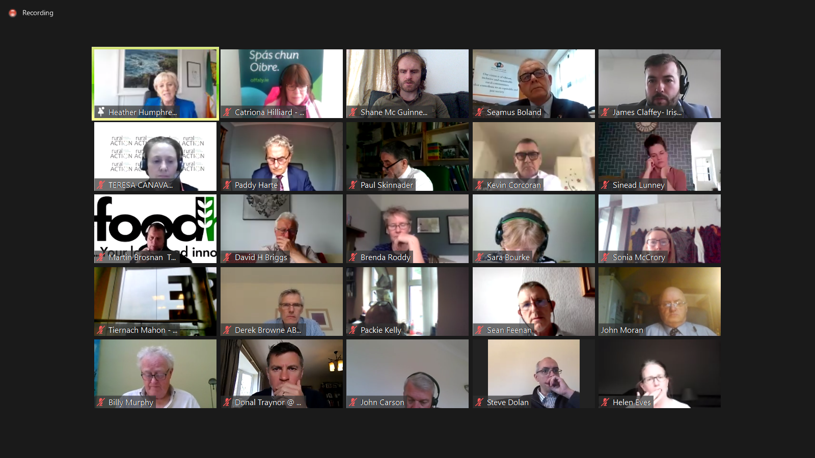

Community Development Principles & Building Capacity Session
This session chaired by Seamus Boland (Irish Rural Link CEO) investigated the skills and resources required by communities to be successful and sustainable. Carol Lambe from Monaghan County Council described its Nurturing Communities Programme which reaches out to communities who are struggling, to work with them through the process of developing a community development plan, helping them to develop their project ideas along the way. Anthony Soares, Centre for Cross Border Studies presented on the challenges that have arisen as a result of COVID-19 and Brexit along with the possible solutions.
Key Messages
There is an assumption that all community groups have the capacity to develop their own solutions, this is not the case. Many groups lack basic community development skills, we must begin delivering training to community groups, north and south.
Consultation process must continuously ask “is there anyone left behind or who we didn’t engage with?”
For communities to be sustainable in the long term, local government must deal with capacity and animate more volunteers.

Thematic Workshops
Participants were given the opportunities to attend two of the five thematic workshops which included Health and Wellbeing, Environmental Challenges, Rural Tourism, Social Enterprises and Smart Villages. Each workshop began with a presentation showcasing a successful project under the relevant theme followed by discussions on challenges and opportunities for cross border cooperation projects. Attendees were also encouraged to use the workshops as an opportunity to meet potential partners. The sections below outline the key messages from each workshop.
All workshop presentations can be viewed through the following link: https://www.irishrurallink.ie/3529-2/
Health and Wellbeing Workshop- Key Messages
There is a lot of media coverage and projects focused on addressing loneliness among older people and not so much on younger people.
Lack of Green space in urban areas – one Meals on Wheels volunteer noticed those with no gardens or living in terrace houses in towns were impacted more than those who had a garden as when they walked out their front door they were in a public space. Need to look at how towns are planned and access to Green spaces must be included and how they are used.
Environmental Challenges Workshop- Key Messages
There is a growing awareness of climate and environmental issues but capacity training is required on ecological knowledge and how to take appropriate action. One participant asked the question ““We need to fill this inside, not outside”; “There’s desire there, but where do we start?”
Environment funding opportunities are relevantly new; more information is needed on how to apply.
Evaluating environmental projects can be difficult for communities, benchmarking against existing projects could be beneficial and safeguard the process of new projects.
Change in overarching policy required– the bottom-up is important but top-down support and investment is crucial to guide the behaviour of individuals.
Rural Tourism Workshop- Key Messages
Participants indicated a requirement for better synchronised funding timelines north and south, funding conditions and requirement should also match for collaboration across jurisdiction to be successful.
Branding and Identity was highlighted as being of particular sensitivity.
Emphasis should be placed on tourist travel pathways through the area as against relying on jurisdiction or administrative boundaries in order to market the region more effectively as a tourist destination.
Social Enterprise Workshop- Key Messages
Rural Communities through Social Enterprise should be encouraged to take more risks and try ideas to find solutions – not always as easy for a private individual (managing risks within reason also important).
Unsurprisingly, procurement was raised as a major issue for cooperation projects. Many organisations believe they don’t have the resources to deal with the administration burden.
Different regulations in the two jurisdictions was again identified as major challenge e.g. VAT Thresholds or trading & non trading allowance by the Charities Commission.
The day to day demands placed on social enterprises can result in a lack of strategic/future thinking.

Smart Villages Workshop- Key messages
The concept of smart villages is not fully understood and people are unaware of the potential. There appears to be more awareness in the south and perhaps opportunity to share learning/experiences with groups in Northern Ireland.
A common understanding and increased awareness of the potential for collaboration around SMART (and cross border) Villages is needed. Some form of strategic and cross border partnership on the theme was recommended.
The European Commission has created a working definition for Smart Villages. They are “communities in rural areas that use innovative solutions to improve their resilience, building on local strengths and opportunities. They rely on a participatory approach to develop and implement their strategy to improve their economic, social and/or environmental conditions, in particular by mobilising solutions offered by digital technologies”.
Participants believe that a standardisation of smart village terminology is required to create a universal approach.
Connecting young people to the concept could create a sense of community ownership and support future succession planning for community development.
Conference Outcomes
Participants welcomed the opportunity to engage in thematic discussions and identified a need for structured networking and sharing practice opportunities on a cross border basis. Irish Rural Link and Rural Action have committed to the following:
- Acting as brokers to assist organisations on both sides of the border to identify project partners.
- Both organisations will host joint thematic webinars in the Autumn to further the conference discussions.
- Assist community groups to arrange study visits. “People need to get out on the ground and see and talk to real people.”

